Lesson Title: Let Me Entertain You!
Grade Level: Kindergarten | Quarter: 1
Standards:
Science:
SKCS5b Begin to draw pictures that portray features of the thing being described.
SKCS4a. Use a model—such as a toy or a picture—to describe a feature of the primary thing.
SKL2.a. Explain the similarities and differences in animals. (color, size, appearance, etc.)

Math:
MCC.K.G.2 Correctly name shapes regardless of their orientations or overall size.

Lesson Essential Question:  How can I observe the similarities and differences in animals?  What are the names of the shapes found in animals? | Vocabulary:  -same  -different  - appearance  -feature  -model  -movement
Lesson Materials  -popsicle sticks  -masking tape, glue, (glue gun—for teacher use only-in high place)  -colored paper and white paper  -feather, foam, pompoms, sequins, wiggly eyes, pipe cleaners—just various craft items you might have on hand (you could also just let them design with markers, crayons, colored pencils.)  -books on habitats chosen  -IPAD, laptops if available | Lesson Assessment:  -student journal  -teacher observation
STEM Challenge Overview:

Students will create 2 puppets that represent animals that live in a habitat and then perform a show. They will also name there shapes used to create their puppets.

Teacher/Student Background:

Students will work in groups of 3-4. We have been working on animals and we have learned that animals live in different places, look differently, and move differently. There are many more ways that animals are similar and different. Students are going to choose an animal habitat and make puppets that represent animals that live in that habitat. Each group will then perform a puppet show for the class.

INSTRUCTION
- Ask/Engage
Day 1 – 45 minutes
- Discuss challenge briefly, reminding students that groups will be presenting a habitat to the class.
- Put names of habitats in bag-grassland, desert, tropical forest, forest, mountains, polar region, lake, ocean, farm—as many groups as you have. Pull habitat names for groups
- You can use this website to introduce children to their different habitats http://www.skyenimals.com/browse_habitat.cgi
- Imagine/Brainstorm
Continue Day 1
Introduce the details of design challenge:
Let me entertain you…Ever wanted to take an African safari or hike through a rainforest? Here is your chance to be our tour guide. Each team member will create 2 puppets that represent animals that live in the habitat your team chooses. You will then perform a puppet show and you-the tour guide- will tell us your animal’s names and then something that is the same and different about your animals. And away with the show!
Introduce criteria:
- Animal must live in the assigned habitat
- Animal must have the correct number of legs
- Animal should have accurate colors
- Animal should include any interesting features
- Animal should include shapes
- Student should demonstrate how the animal moves using the puppet

Have students brainstorm in their journal the animal puppets they might like to make. Students should draw pictures of several animals that live in their assigned habitat.

- Students should research using books, laptops or IPADS (if available) your specific habitats to see what type of animals live there.
- Students should be sure to look at number of legs, coverings, how it moves, size, or any other interesting feature so you can make your puppet accurate.
- Preview craft materials that might be available to make your puppet

- Plan/Design
Continued Day 2
- Each student presents their ideas to the team.
- Group will decide what animal puppets to make. Be careful to have only one of each animal.
- Use your student journal to make a final sketch of your 2 animal puppets including shapes
- On the animals name three shapes
- Create / Test
Day 3 and 4
- Students will create puppets
- Practice puppet show—giving your animals name and one thing that is the same and different for your animals.
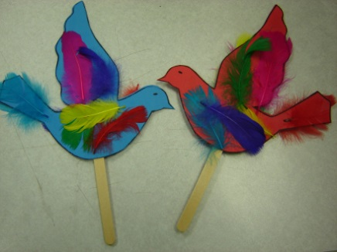
- Evaluate/Improve – and repeat Steps 1-5
Day 5 and 6
- Groups will present puppet shows-if you do not have a puppet theater-use a table
- Students will complete student journal

Extension-
- Students could create a picture showing the habitat that their animal lives on the computer using a drawing program such as KidPix4
- How to make puppets and about puppeteers-Jim Henson 14. Min long http://www.youtube.com/watch?v=AC440k6iByA

