Lesson Title: Weather Channel Interview
Grade Level: 4 | Quarter: 3
Standards:

Science:
S4E4 Students will analyze weather charts/maps and collect weather data to predict weather events and infer patterns and seasonal changes.
b. Using a weather map, identify the fronts, temperature, and precipitation and use the information to interpret the weather conditions.
c. Use observations and records of weather conditions to predict weather patterns throughout the year.

Technology:
4T1b. Create original works as a means of personal or group expression.
With Assistance:
4T1b1. Students will create a digital work (e.g., movie, podcast, digital storytelling, web publishing, etc.), individually or collaboratively about a specific topic using primary resources and secondary resources.

Lesson Essential Question:  - How do I use weather maps to make predictions about future weather events?  - How do I create a digital work? | Vocabulary:  Weather, Climate, Weather Map, High Pressure System, Low Pressure System, Cold Front, Warm Front, Stationary Front, Precipitation, Temperature, Meteorologist
Lesson Materials:  Weather Map PowerPoint Presentation  SmartBoard (for student forecasts)  Printed Weather Maps for each group (attached to this lesson)  Video camera/iPad  Stop watches | Lesson Assessment:  Student STEM journal  Completed video of weather forecast  Teacher observations
STEM Challenge Overview:

Teams will be interviewing for a spot on The Weather Channel to be featured in their “Climate Kids” segment. They are looking for kids who can forecast the weather accurately by analyzing weather charts/maps.

Teacher Background:

Students will need experience with weather maps, symbols, fronts, and the language of weather. Watching several meteorologists as they present weather reports (www.weather.com) will provide some background knowledge related to forecasting needed for students to prepare a forecast.

Students will need to be grouped in teams of 3-4. You may wish to assign roles (or allow students to decide the roles based on their strengths) Roles for this task may include:
Camera Person- will video tape
Reporter/Meterologist-will give the weather forecast
Director(s)- will manage the script and technology while the forecast is taking place.

Students can present their weather report through a PowerPoint file – or print to your Smart Board file.

INSTRUCTION
- Ask/Engage
Day 1 (20-30 min)
Show students videos of weather forecasts from www.weather.com or www.wsbtv.com or www.accuweather.com
After watching several videos, create an anchor chart or Smart Board file of the common characteristics of a good weather forecast.
Probing questions:
What types of things did the weather person say?
What type of attitude did the weather person have? (serious, silly)
How did they look?
Did they look at the camera or at their notes?
How did they use the weather maps in the background?
Besides the information about the weather, what other things do you think a meteorologist uses when he/she predicts the weather? Do they need to know cardinal directions? Where the states or important land/water features are located?
Is the person talking about weather on the video the only person involved with making the forecast?
What other jobs are there behind the camera?

Introduce the challenge to the students and have them complete the ask/engage part of their student journal.
Challenge:
The Weather Channel is looking to hire a forecast team to present the weather on a new show called “CLIMATE KIDS”. You will be interviewing for this job by preparing a forecast and creating a “screen-test” for the class to view. Your job will be to forecast the weather accurately by analyzing weather charts/maps. Good luck, have fun and remember to smile for the camera!

- Imagine/Brainstorm
Day 2 (10-15 min)
Students work independently to analyze the weather maps (attached to the lesson). Some questions that you might post include:

- Using the weather map what can you determine is the same on all of the maps? Different?
- Identify the fronts.
- What are the temperatures on the maps?
- Are there any areas / regions are being affected by precipitation?
- Are there any areas / regions are experiencing clear skies?
- What might the weather be like tomorrow?

Have students record their thoughts / ideas in their STEM journal.

Criteria:
1. Written script for weather forecast
2. Screen Test
3. Accurate weather forecast

Constraints:
1. Video is at least 2-3 minutes in length
2. Complete the challenge in the time allotted

- Plan/Design
Day 2 Continued (10-20 min)
Students join their teams to discuss their findings from the weather maps. As a team, they determine what the next day’s forecast should be and begin writing a script for the weather person’s forecast. When writing the script be sure to discuss the speed of the fronts. How many miles per hour is the front moving? Although only one person from the group will be the meteorologist who presents the forecast, all team members are responsible for the script. Be sure the script can be delivered within two to three minutes.

- Create / Test
Day 3 (45 min – 1hr)
Working as a team, students should finish writing scripts for the forecast and begin rehearsals. Camera Persons may need to attend a “Camera Training” session (teacher may want to show students how to operate the camera and discuss with these students any rules / information they feel is important while other students are preparing)

- Evaluate/Improve – and repeat Steps 1-5
Day 3 Continued
Students evaluate their design for success. Did it meet the established criteria? Did their final design match their planned design? How would students improve their design?

Extension: Write a letter of recommendation to the Weather Channel for the news crew you feel gave the best and most accurate forecast. Provide examples from the presentation. Remember the entire crew is being hired – not just the person in the video.

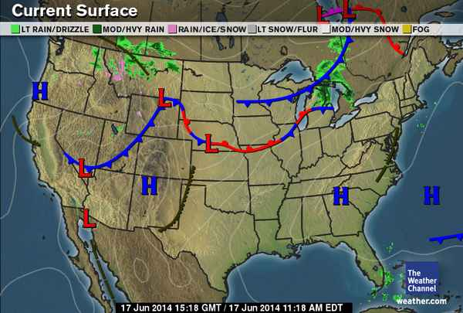
Monday
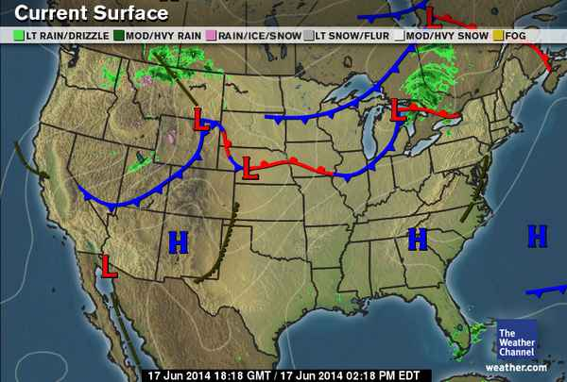
Tuesday

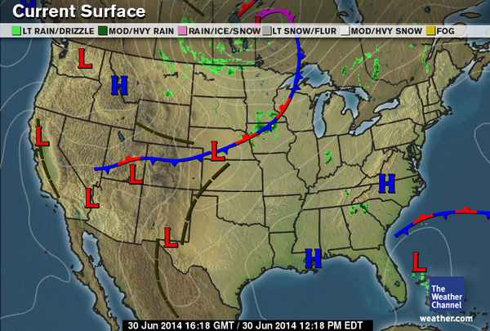
Wednesday

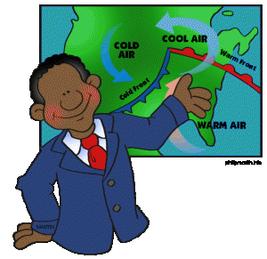
Name__________________

Weather Channel Interview
STEM Challenge
4th Grade

Challenge:
The Weather Channel is looking to hire a forecast team to present the weather on a new show called “CLIMATE KIDS”. You will be interviewing for this job by preparing a forecast and creating a “screen-test” for the class to view. Your job will be to forecast the weather accurately by analyzing weather charts/maps. Good luck, have fun and remember to smile for the camera!

Criteria:
1. Written script for weather forecast
2. Screen Test
3. Accurate weather forecast

Constraints:
1. Video is at least 2-3 minutes in length
2. Complete the challenge in the time allotted

Materials:
Video Camera/iPad, Weather Maps, Stop Watches
ASK / ENGAGE: What is the problem you are being asked to solve?
________________________________________________________________________________________________________________________________________________________________________________________________________________________________________________________________________________________________________________________________________________________________________________________________________
- IMAGINE/BRAINSTORM: What are some possible solutions to the problem that you are trying to solve? After you brainstorm, draw and label your ideas below.
Things I notice about the maps: | My forecast predictions

- PLAN/DESIGN: Share your ideas with your group and collaborate to decide on a final design plan. Draw your team’s design below and make a list of the materials that you will need to complete your design.
Team Forecast: | What jobs do we have?  Reporter:  Camera Person:  Director:  Director:

- CREATE/TEST: Work with your team to create a script for you forecast. Practice the forecast. Working as a team, you will need the camera person to video, the reporter to read the script, and the directors to help handle all the “behind-the-scenes” needs. Record notes about the Why or Why not?
____________________________________________________________________________________________________________________________________________________________________________________________________________________________________________________________________________________________________________________________________________________________________________
- EVAULATE/IMPROVE: How well did your forecast work? Did your solution solve the problem within the given constraints?
_____________________________________________________________________________________________________________________________________________________________________________________________________________________________________________________________________________________________________________________________________________________________________________________________________________________________________________________________________________________________________________________________________________________________________________________________________________________________________________________________
How can you improve your design? How can you make it better? Draw and label your improved design below.

Improved Plan

